Group B – Thursday 1:15-4:15 PM

Team Members: Matthew Davis, Timothy Hunt, Bryan Metlesitz, Brian Robb

Foreman: Matthew Davis

Consultants: TA- Omar, Professor- Dr. Wainright

Case Western Reserve University

10900 Euclid Ave. Cleveland, OH 44106

November 3, 2011

Heat Exchanger

Foreman’s Report

**Safety Considerations**

The use of proper safety equipment and measures is of the utmost importance during this experiment. For apparel this encompasses the use of both safety glasses and a lab coat. As the apparatus utilized in this lab involves high temperatures, certain precautions need to be taken when in the vicinity of the equipment. Exposed temperatures can be in the range of 100 to 150°C. Proper glove protection should be worn when handling any part of the apparatus. The provided gloves in the pilot plant are made by Westchester and are composed of both cotton and leather. The temperature threshold is up above 200°C.

There are three different degrees of burns possible. A first degree burn affects only the outer layer of the skin and it causes pain, redness, and swelling. A second degree burn affects both the outer and underlying layer of skin, it causes pain, redness, swelling, and blistering. A third degree burn extends into deeper tissues; it causes white or blackened charred skin that may be numb. If a burn does occur, the treatment is as follows for a first or second degree burn:

1. Immediately submerge the affected par in cold water until the pain decreases
2. Cover the burned area with a clean and dry bandage
3. If available, contact a medical person

If a facial or third degree burn occurs, do not wet the affected area. Immediately cover the burned area with a bandage. If facial, check for breathing. (<http://www.nlm.nih.gov/medlineplus/ency/article/000030.htm>) Contact medical aid immediately, by calling campus security (216-368-3333).

The lab will have multiple experiments being run at the same time, thus the potential danger is increased. The area allocated for the lab needs to be organized and hazard, free. Every team member must be cautious of their surrounds when dealing with structure involved with the experiment. If there is an accident the group needs to know the problem and how to act accordingly as to avoid injury. The two best exits in the case of an accident are either the fire door or the machine shop.

There are no vapor or chemical hazards associated with this experiment. However, there are equipment and physical hazards associated with this experiment. The water inlet hoses can be blown off due to either a loose fitting hose or pressure build up. The equipment involved with the fluid streams needs to be constantly monitored and checked for leaks. All the fixtures need to be checked for security. All the valves need to be monitored for a secure connection. Due to the fact that some of the piping is thin in certain areas, while attaching hoses, two team members must be present. One person will secure and support the piping while the other attaches the hose. Appropriate hoses need to be used to prevent both tripping and possible blockage which would result in a pressure build up.

Although some water and steam leakage is unavoidable, major leaks should be reported and the system shut down. In case of an emergency, the TA should be immediately notified and inlet flows need to be shut off.

**Apparatus**

The apparatus used in this experiment includes both shell-and-tube heat exchangers and plate and frame heat exchangers. There is access to both a cold-water source and a hot water source. Each input and output on all the heat exchangers is fitted with thermocouples for accurate temperature data. There are flow rate indicators connected to the inputs and outputs of the connection columns.

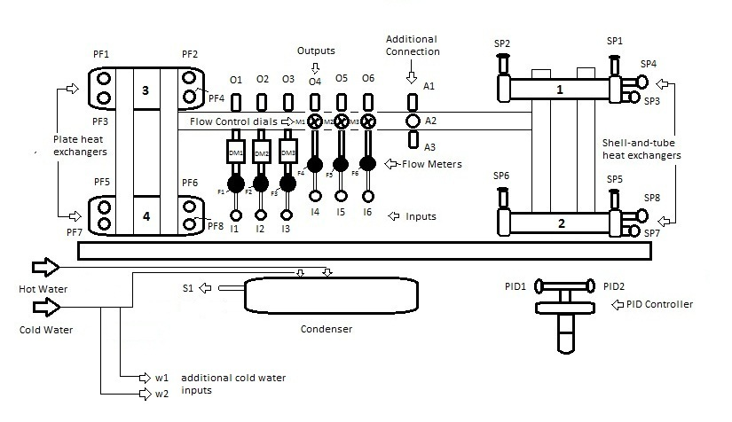

*Figure 1: Entire Heat Exchanger Setup, containing all input and output connections*

The process will be controlled through use of LabVIEW 8.5, with the file name “NewHeatExchanger2011 1.1.vi” found at “C:\Documents and Settings\craig virnelson\Desktop\NewHeatExchanger2011 1.1.vi.” Through the VI interface, our team will be able to both control the flow rates and monitor the temperatures of the streams. Section 1 monitors the various flow rates utilized in the trial by both numerical and graph indicators. Section 2 monitors the various thermocouples attached to the heat exchangers. Sensors will be calibrated by Craig Virnelson (lab manager) before the start of the lab through a PID controller. Section 4 is file path where all experimental data will be recorded.

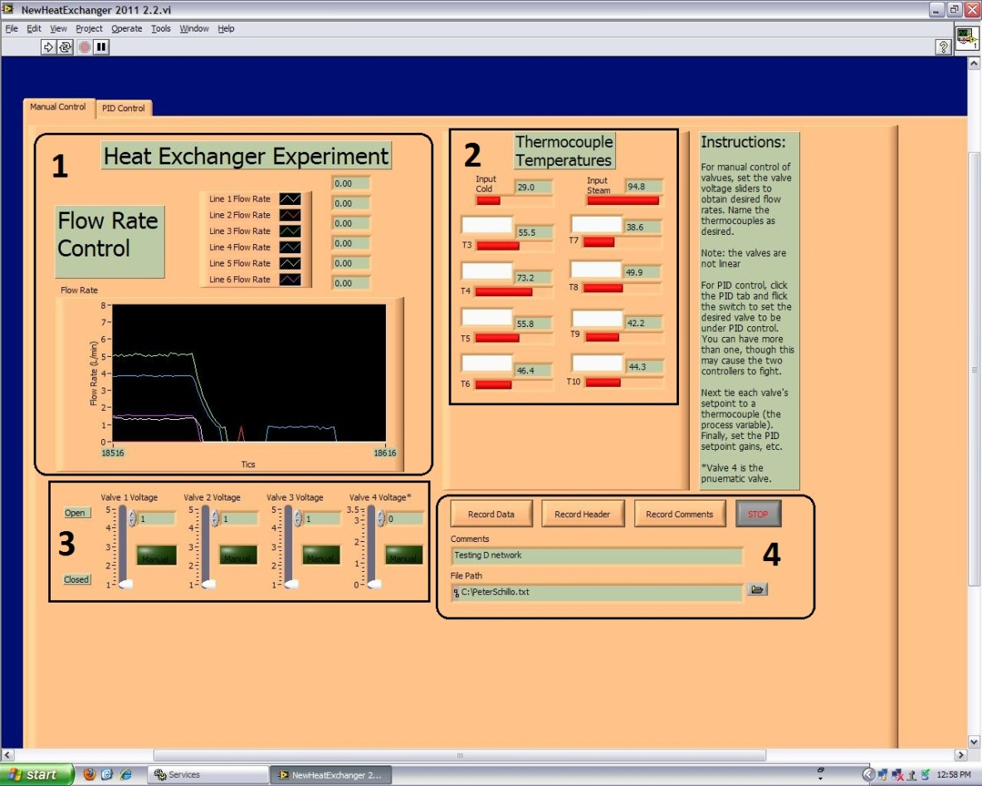

*Figure 2: Manual Control LabVIEW VI.*

The LabVIEW VI is connected to the physical system through a National Instruments Elvin II proto board. This instrument allows the recording of accurate data for both the temperature and flow rates.

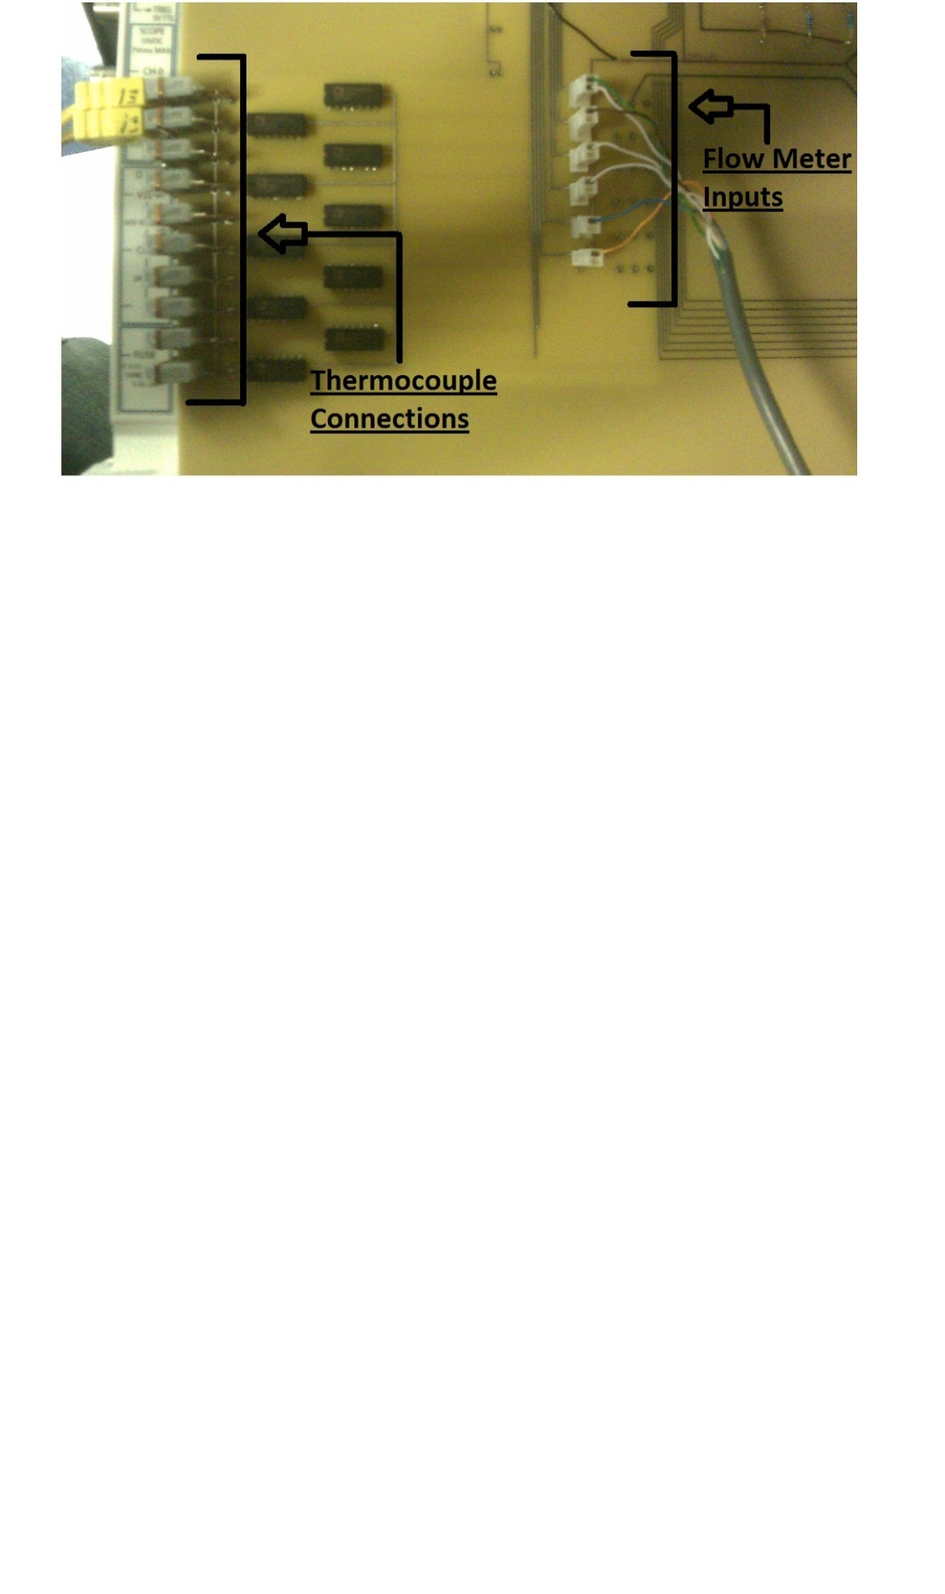

*Figure 3: NI ELVIS II Proto Board allows inputs for both thermocouples and flow meters.*

The thermocouples (figure 3) are attached to each exchanger in four places, as well as the inlet and outlet temperatures of the system. For each heat exchanger, the thermocouples are attached to the heat inlet, the cold inlet, the heat outlet, and the cold outlet. Each thermocouple is labeled with a letter and a number; this indication will allow the team to recognize which thermocouple is attributed to a specific heat exchanger. The specific temperatures can be seen in the VI in section 2 (figure 2). In order to recognize each specific stream the thermocouples will be plugged in one at a time during the beginning of the process.

**Procedure**

Before starting, an inspection will take place to insure that the equipment is in proper condition for the experiment. All of the valves will be checked to make sure they are closed. All of the inlet hoses will be checked to ensure they are fitted properly and no leaks occur. Ensure that cold water is running through every active part (condenser and heat exchangers) before connecting the hot flow during each trial.

**Part 1**

The first task will be to distinguish the overall heat exchange coefficient “U” for each of the exchangers in the lab. This will allow the optimization of the network. This will be done by running five trials for each of the individual heat exchangers. The heat exchangers will be tested in the numerical order indicated in Figure 1. Before the trials an initial inspection of valve position will be performed. The valves will first be placed before the heat exchanger, then after the heat exchanger. The U values will be observed, and then the position of the valves will be determined for the trial runs. The trials will be conducted in either of the two manners depending on the position of the flow sensors and valve controllers (before or after) for each individual heat exchanger once it reaches steady state:

**Case 1**

1. A connection between S1, the hot water input and I3 will be established.
2. O3 will then be plugged into the specific heat exchanger for the hot flow rate.
3. A connection between w1, the cold water input and I2 will be established.
4. O2 will then be plugged into the specific heat exchanger for the cold flow rate.
5. The hot water output from the specific heat exchanger will be be connected to the drain.
6. The cold water output from the specific heat exchanger will be connected to the drain.

**Case 2**

1. A connection between S1 and the individual heat exchanger will be made.
2. The outlet of the hot water flow will be connected to I3.
3. O3 will be plugged into the drain.
4. A connection between w1 and the individual heat exchanger will be made.
5. The outlet of the cold water flow will be connected to I2.
6. O2 will be plugged into the drain.

For each of the four heat exchangers, the incoming flow rates will be varied to change the inlet and outlet temperatures of each exchanger. In order to vary the flow rate, each exchanger will run at varying voltage sequences for the hot and cold streams. In order to determine the association of valve position, the flow rate will be quickly tested at each voltage increment.

The following table represents the varying flow rates for each trial for the four different heat exchangers. In order to avoid pinching in the majority of the trials, the cold flow rate will be higher than the hot flow rate.

|  |  |  |
| --- | --- | --- |
| **Trial** | **Hot Flow Rate In (L/min)** | **Cold Flow Rate In (L/min)** |
| **1** | 2 | 5 |
| **2** | 3 | 5 |
| **3** | 4 | 5 |
| **4** | 4 | 4 |
| **5** | 5 | 4 |

The experimental data will be tested after each run with the excel sheet to check the desired values of Q and U.

**Part 2**

ChemCAD version 6.3.0.3903 was utilized to design the optimal heat exchanger network that would minimize the use of cooling water. This design will be tested at the pilot plant for comparison to theoretical data.

This design will be run at 5.3L/min and 80°C. Two product streams must be produced. The first requires a temperature of 40 ± 2.0℃ and its flow rate is to be 3.3 ± 0.2 L/min. The second requires a temperature of 55 ± 2.0℃ and its flow rate is to be 2.0 ± 0.2 L/min.

The following equations were used to obtain the heat exchange coefficient of the ChemCAD simulations. The first equation is the steady-state heat duty which is specified by:

Q = mCp(Tout – Tin) (1)

where Q is the heat duty, m is the flow rate of the stream, Cp is the fluid heat capacity, and T is the temperature for the inlet and outlet streams. When a phase change occurs, eq 1 is replaced or augmented by the heat of vaporization or condensation, Q=mΔHvap.

When streams on both sides of a heat exchanger are considered in process design, a two-sided heat exchanger model is used. All of the heat released by one side is taken up by the other side. In addition, a transport equation is applied:

Q = UA ∆Tlm (2)

where U is the overall heat transfer coefficient, A is the area for heat transfer, and ∆Tlm is the log-mean temperature-driving force for heat transfer. ∆Tlm is the temperature difference between the two streams at the inlet, and *ΔTB* is the temperature difference between the two streams at the outlet.

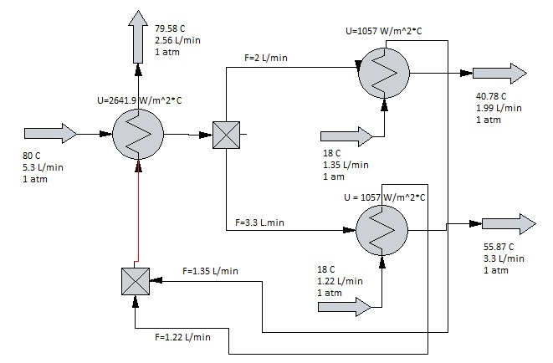

*Figure 4: Optimal heat exchanger process, yielding the required streams with minimum amount of cold water.*